DOM Manipulation Methods in jQuery

jQuery provides various methods to add, edit or delete DOM element(s) in the HTML page.

The following table lists some important methods to add/remove new DOM elements.

| Method | Description |
| --- | --- |
| append() | Inserts content to the end of element(s) which is specified by a selector. |
| before() | Inserts content (new or existing DOM elements) before an element(s) which is specified by a selector. |
| after() | Inserts content (new or existing DOM elements) after an element(s) which is specified by a selector. |
| prepend() | Insert content at the beginning of an element(s) specified by a selector. |
| remove() | Removes element(s) from DOM which is specified by selector. |
| replaceAll() | Replace target element(s) with specified element. |
| wrap() | Wrap an HTML structure around each element which is specified by selector. |

The following figure shows how the DOM manipulation methods add new elements.

[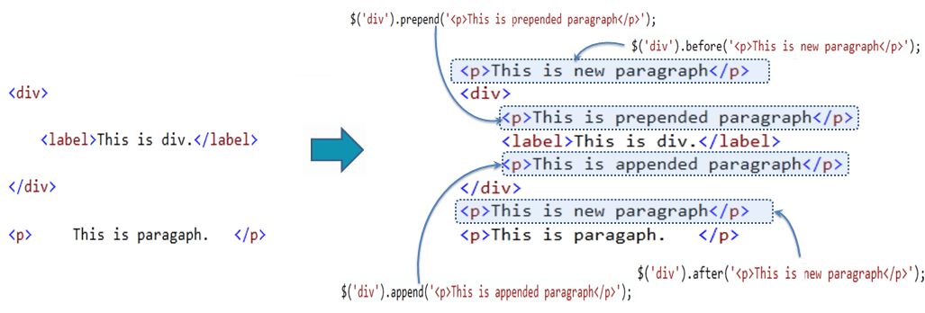](https://www.tutorialsteacher.com/Content/images/jquery/manipulation-methods.png)DOM Manipulation Methods

jQuery after() Method

The jQuery after() method inserts content (new or existing DOM elements) after target element(s) which is specified by a selector.

Syntax:

$('selector expression').after('content');

First of all, specify a selector to get the reference of target element(s) after which you want to add the content and then call after() method. Pass the content string as a parameter. Content string can be any valid HTML element.

Example: jQuery after() Method

$('#div1').after('<div style="background-color:yellow"> New div </div>');

<div id="div1">div 1

</div>

<div id="div2">div 2

</div>

Result:

<div id="div1">div 1

</div>

<div style="background-color:yellow"> New div </div>

<div id="div2">div 2

</div>

jQuery before() Method

The jQuery before() method inserts content (new or existing DOM elements) before target element(s) which is specified by a selector.

Syntax:

$('selector expression').before('content');

Specify a selector to get the reference of target element(s) before which you want to add the content and then call before() method. Pass the content string that can be any valid HTML element as parameter.

Example: jQuery before() Method

$('#div1').before('<div style="background-color:yellow"> New div </div>');

<div id="div1">div 1

</div>

<div id="div2">div 2

</div>

[Try it](https://www.tutorialsteacher.com/codeeditor?cid=jquery-32)

Result:

<div style="background-color:yellow"> New div </div>

<div id="div1">div 1

</div>

<div id="div2">div 2

</div>

ADVERTISEMENT

jQuery append() Method

The jQuery append() method inserts content to the end of target element(s) which is specified by a selector.

Syntax:

$('selector expression').append('content');

First specify a selector expression to get the reference of an element(s) to which you want to append content, then call append() method and pass content string as a parameter.

Example: jQuery append() Method

$('p').append('World!');

<p>Hello </p>

[Try it](https://www.tutorialsteacher.com/codeeditor?cid=jquery-33)

Result:

<p>Hello World!</p>

jQuery prepend() Method

The jQuery prepend() method inserts content at the beginning of an element(s) specified by a selector.

Syntax:

$('selector expression').prepend('content');

First specify a selector expression to get the reference of an element(s) to which you want to prepend the content, then call prepend() method and pass content string as a parameter.

Example: jQuery prepend() Method

$('div').prepend('<p>This is prepended paragraph</p>');

<div>

<label>This is div.</label>

</div>

[Try it](https://www.tutorialsteacher.com/codeeditor?cid=jquery-34)

Result:

<div>

<p>This is prepended paragraph</p>

<label>This is div.</label>

</div>

jQuery remove() Method

The jQuery remove() method removes element(s) as specified by a selector.

Syntax:

$('selector expression').remove();

First specify a selector expression to get the reference of an element(s) which you want to remove from the document and then call remove() method.

Example: jQuery remove() Method

$('label').remove();

<div>This is div.

<label>This is label.</label>

</div>

[Try it](https://www.tutorialsteacher.com/codeeditor?cid=jquery-35)

Result:

<div>

This is div.

</div>

jQuery replaceAll() Method

The jQuery replaceAll() method replaces all target elements with specified element(s).

Syntax:

$('content string').replaceAll('selector expression');

Here, syntax is different. First specify a content string as replacement element(s) and then call replaceAll() method with selector expression to specify a target element(s).

Example: jQuery replaceAll() Method

$('<span>This is span</span>').replaceAll('p');

<div>

<p>This is paragraph.</p>

</div>

<p>This is another paragraph.</p>

[Try it](https://www.tutorialsteacher.com/codeeditor?cid=jquery-36)

Result:

<div>

<span>This is span</span>

</div>

<span>This is span</span>

jQuery wrap() Method

The jQuery wrap() method wrap each target element with specified content element.

Syntax:

$('selector expression').wrap('content string');

Specify a selector to get target elements and then call wrap method and pass content string to wrap the target element(s).

Example: jQuery wrap() Method

$('span').wrap('<p></p>');

<div>

<span>This is span.</span>

</div>

<span>This is span.</span>

[Try it](https://www.tutorialsteacher.com/codeeditor?cid=jquery-37)

Result:

<div>

<p> <span>This is span.</span></p>

</div>

<p><span>This is span.</span></p>